A Minor Project (Phase I) Report On

BANK LOAN ANALYSIS
Submitted to
CHHATTISGARH SWAMI VIVEKANAND TECHNICAL UNIVERSITY, BHILAI

in partial fulfillment of requirement for the award of degree of
Bachelor of Technology
In
CSE(AL&ML)
SEMESTER 5th
By
Abhishek Kumar Gupta 301310923OO7 CD2085

Under the Guidance of Dr. Rupesh Mishra
Associate Professor and
Co Hod, CSE AI/AIML


DEPARTMENT OF CSE(AL &ML)

RUNGTA COLLEGE OF ENGINEERING & TECHNOLOGY, KOHKA-KURUD ROAD, BHILAI, CHHATTISGARH, INDIA

Session : 2025-2026

D E C L A R A T I O N

I , the undersigned , solemnly declare that this report on the project
work entitled “ BANK LOAN ANALYSIS ”, is based on my own work carried out during the course of my study under the guidance of Dr Rupesh Mishra .

I assert that the statements made and conclusions drawn are an outcome of the project work. I further declare that to the best of my knowledge and belief the report does not contain any part of any work which has been submitted for the award of any other degree in this University or any other University.

Abhishek Kumar Gupta
301310923007
CD2085

C E R T I F I C A T E

This is to certify that this report on the project submitted is an outcome of the
project work entitled “BANK LOAN ANALYSIS”, carried out by the student in the DECLARATION , is carried out under my guidance and supervision for the award of Degree in Bachelor of Technology in CSE (AI & ML) of Chhattisgarh Swami Vivekanand Technical University, Bhilai(C.G.), India.

To the best of my knowledge , the report …

i) Embodies the work of the students themselves,

ii) Has duly been completed,

iii) Fulfil ls the requirement of the Ordinance relating to the B.Tech degree of the University , and

iv) Is up to the desired standard for the purpose for which it is submitted.

Dr. Rupesh Mishra
Associate Professor and
Co Hod, CSE AI/AIML

This project work as mentioned above is hereby being recommended and
forwarded for examination and evaluation by the University ,

Dr. Padmavati Shrivastava
Head ,
Department of CSE (AI/AIML) ,
Rungta College of Engineering & Technology ,
Kohka - Kurud Road, Bhilai (C.G.) , India

C E R T I F I C A T E B Y T H E E X A M I N E R S

This is to certify that this project work entitled “ BANK LOAN ANALYSIS ” , submitted by …

Abhishek Kumar Gupta 301310923007 CD2085

is duly examined by the undersigned as a part of the examination for the award of Bachelor of Technology degree in CSE(AL&ML) of Chhattisgarh Swami Vivekanand Technical University, Bhilai.

Internal Examiner External Examiner
Name & Signature Name & Signature

Date: Date:

A C K N O W L E D G E M E N T S

It is a matter of profound privilege and pleasure to extend my sense of respect and deepest
gratitude to my project guide Dr. Rupesh Mishra, Department of CSE AI / AIML under
whose precise guidance and gracious encouragement I had the privilege to work.

I avail this opportunity to thank respected Dr Padmavati Shrivastava , Head of the
Department of CSE AI /AIMI for facilitating such a pleasant environment in the department
and also for providing everlasting encouragement and support throughout.

I acknowledge with the deep sense of responsibility and gratitude the help rendered by
respected Dr. Manish Manoria, Director General, Rungta Educational Foundation, Bhilai, Dr.
Y. M. Gupta, Director(Academics) , and Dr. Chinmay Chandrakar, Dean(Academics) , of
Rungta College of Engineering and Technology , Bhilai for infusing endless enthusiasm &
instilling a spirit of dynamism .

I would also like to thank all faculty members of my department , and the supporting staff
for always being helpful over the years.

Last but not the least, I would like to express my deepest gratitude to my parents and the
management of Rungta College of Engineering and Technology , Bhilai , respected Shri
Santosh Ji Rungta, Chairman, respected Dr. Sourabh Rungta, Vice Chairman , and respected
Shri Sonal Rungta , Secretary , of Rungta Educational Foundation, Bhilai for their continuous
moral support and encouragement.

I hope that I will make everybody proud of my achievements .

Abhishek Kumar Gupta, 301310923007, CD2085

Table of Contents

Declaration i
Certificate ii
Certificate by Examiners iii
Acknowledgements iv

Chapter Title Page No.

1 Introduction 1 - 4

2 Literature Review 5 - 6

3 Problem Identification 7 - 7

4 Methodology 8 - 13

5 Results 14 - 19

6 Conclusion And Future 20 - 29
Scope

Appendix 30 - 35

Reference 36 - 36

Abstract
The banking sector plays a pivotal role in economic development by providing financial support through various loan products. However, loan disbursement involves significant risk due to the possibility of borrower default. Effective bank loan analysis is therefore essential for evaluating borrower creditworthiness, minimizing credit risk, and improving overall loan performance. This project focuses on analyzing a bank loan dataset to identify key factors that influence loan approval decisions and repayment behaviour.
The dataset used in this study contains detailed information related to applicants, including demographic attributes, income levels, employment status, credit history, loan amount, and loan status. Data preprocessing techniques such as handling missing values, removing inconsistencies, and transforming variables were applied to ensure data quality. Exploratory Data Analysis (EDA) was performed to understand patterns, trends, and relationships among variables affecting loan approval and default risk.
Advanced analytical techniques and visualizations were implemented using Power BI, where key performance indicators (KPIs) such as loan approval rate, rejection rate, average loan amount, and default rate were calculated using DAX measures. Interactive dashboards were developed to provide insights into customer segmentation, risk assessment, and loan performance.
The results of the analysis reveal that credit history, applicant income, and employment type are among the most influential factors in determining loan approval. This project demonstrates how data-driven analysis can support banks in making informed lending decisions, reducing non-performing assets, and improving operational efficiency. The findings highlight the importance of analytical tools in modern banking for effective risk management and strategic decision-making.

CHAPTER 1: INTRODUCTION

1.1 Overview of Banking and Loan System
Banks act as financial intermediaries between depositors and borrowers. They mobilize savings and allocate funds efficiently across various sectors of the economy. Loans are classified into different types such as personal loans, home loans, education loans, vehicle loans, and business loans. Each type of loan has different risk characteristics and approval criteria.

1.2 Importance of Loan Analysis in Banking

Loan analysis is essential for:
● Assessing borrower creditworthiness
● Reducing loan default probability
● Ensuring long-term profitability
● Maintaining liquidity and capital adequacy
Banks increasingly rely on analytical techniques instead of manual judgment to ensure accuracy and consistency.

1.3 Problems Faced by Traditional Loan Systems
Traditional loan approval systems face several challenges:
● Subjective decision-making
● Delays in processing
● Higher operational costs
● Increased risk of defaults
These challenges emphasize the need for automated and analytical systems.

1.4 TOOLS AND TECHNOLOGIES USED
The selection of Power BI is critical for providing dynamic, interactive visualization capabilities.
- Data Transformation: Power Query for initial cleaning and shaping.

- Data Modeling and Metrics: DAX (Data Analysis eXpressions) for advanced calculations.

- Visualization and Reporting: Power BI Desktop.

- Data Source: Bank Personal Loan Modelling Dataset (CSV Format).

1.5 Role of Data Analytics in Banking
Data analytics enables:
● Pattern recognition in customer behaviour
● Risk segmentation
● Fraud detection
● Performance monitoring
Modern banks integrate analytics with decision support systems.

1.6 Objectives of the Study
Primary objectives:
● Analyze loan approval patterns
● Identify default risk factors
● Build interactive dashboards
● Apply DAX measures for KPIs

Secondary objectives:
● Improve transparency
● Support strategic decisions

1.7 Scope of the Project
The study is limited to historical loan data and focuses on retail banking loans. The analysis does not include real-time transactions or external economic indicators.
1.8 Structure of the Report
This report consists of six chapters covering introduction, literature review, problem identification, methodology, results, and conclusion.

CHAPTER 2 : LITERATURE REVIEW

2.1 Review of Existing Research
Several researchers have studied loan default prediction using:
● Statistical models
● Logistic regression
● Machine learning techniques
Most studies highlight income, credit history, and employment status as critical factors.

2.2 Credit Risk Management Studies
Credit risk is defined as the probability of loss due to borrower default. Literature emphasizes:
● Credit scoring models
● Risk-based pricing
● Portfolio diversification

2.3 Use of Business Intelligence Tools
Recent studies show the increasing adoption of BI tools like Power BI and Tableau for banking analytics due to:
● Interactive dashboards
● Real-time reporting
● Visual storytelling

2.4 Gaps Identified in Literature
● Limited use of integrated Python + Power BI workflows
● Lack of dashboard-based performance tracking
● Minimal focus on explainability

2.5 Contribution of the Present Study
This project bridges the gap by combining:
● Python-based data preprocessing
● Power BI visualization
● DAX-driven KPI evaluation

CHAPTER 3: PROBLEM IDENTIFICATION

3.1 Statement of the Problem
Banks face increasing loan defaults due to inadequate risk assessment and poor monitoring mechanisms.

3.2 Key Issues Identified
● Rising NPAs
● Inefficient approval process
● Limited analytical insights

3.3 Need for Analytical Loan Assessment
Data-driven analysis helps banks:
● Predict risky borrowers
● Optimize loan portfolios
● Improve approval accuracy

3.4 Expected Outcomes

● Improved approval efficiency
● Reduced default rates
● Better decision support

CHAPTER 4: METHODOLOGY

4.1 Data Collection

4.1.1 Dataset Source
The dataset was obtained from Kaggle and represents anonymized bank loan records. Available :
“https://www.kaggle.com/datasets/anmolkumar/analytics-vidhya-loan-prediction?utm_source=chatgpt.com&select=train.csv”

4.1.2 Dataset Attributes (Detailed Table)

A) Loan_ID :- Loan_ID is a unique identifier assigned to each loan application.It is used to uniquely distinguish and track individual loan records in the dataset.This column has no analytical or predictive value and is mainly used for record identification and counting purposes.

B) Gender :- Gender represents the gender of the loan applicant (Male or Female).It is a categorical demographic variable used to analyze differences in loan approval patterns across genders.This column helps in understanding whether gender has any influence on loan approval decisions.

C) Income :- Income represents the total earnings of the loan applicant, including both applicant and co-applicant income.It reflects the financial capacity of the borrower to repay the loan.Higher income generally indicates lower risk for the bank and improves the chances of loan approval.

D) Credit Score :- Credit Score represents the applicant’s past loan repayment behavior and financial discipline.It indicates whether the applicant has a good (1) or poor (0) credit history.A higher credit score signals lower default risk, making the applicant more likely to get loan approval.

E) Loan Amount :- Loan Amount represents the total amount of money requested by the applicant from the bank.It reflects the size of financial assistance required for purposes such as housing or personal needs.Higher loan amounts generally involve greater risk, which can reduce approval chances if not supported by strong income and credit history.

F) LoanStatus :- LoanStatus indicates whether the applicant’s loan was approved or rejected by the bank.It is a target or outcome variable, typically coded as Y (Approved) and N (Rejected).This column is crucial for analyzing approval patterns and building predictive models on loan eligibility.

4.2 Data Preprocessing in Google Colab

4.2.1 Data Cleaning Process
● Removal of null values
● Imputation techniques
● Outlier detection
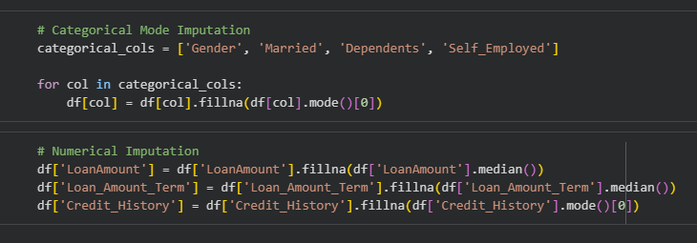

4.2.2 Data Transformation
● Label encoding
● Feature scaling

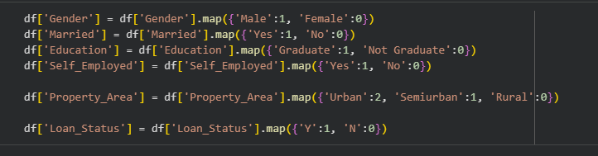

4.2.3 Python Libraries Used
NumPy, Pandas, Matplotlib, Seaborn.

4.3 Exploratory Data Analysis

● Distribution analysis
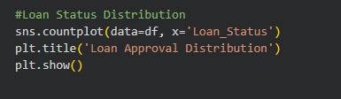

● Correlation analysis
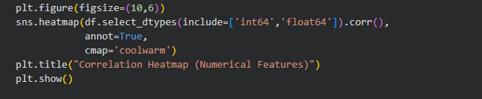
● Trend identification
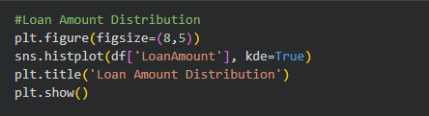

4.4 Power BI Analysis
● Data Import and Modelling
● Relationship Creation
● Calculated Columns

4.5 DAX Measures :

- Total Applications = COUNT('clean_loan_data'[Loan_ID])

- Approved Loans = CALCULATE(COUNT('clean_loan_data'[Loan_ID]), 'clean_loan_data'[Loan_Status] = 1)

- Rejected Loans = CALCULATE(COUNT('clean_loan_data'[Loan_ID]), 'clean_loan_data'[Loan_Status] = 0)

- Approval Rate = DIVIDE ([Approved Loans], [Total Applications], 0)

- Average Loan Amount = AVERAGE('clean_loan_data'[LoanAmount])

- Average Total Income = AVERAGE('clean_loan_data'[Total_Income])

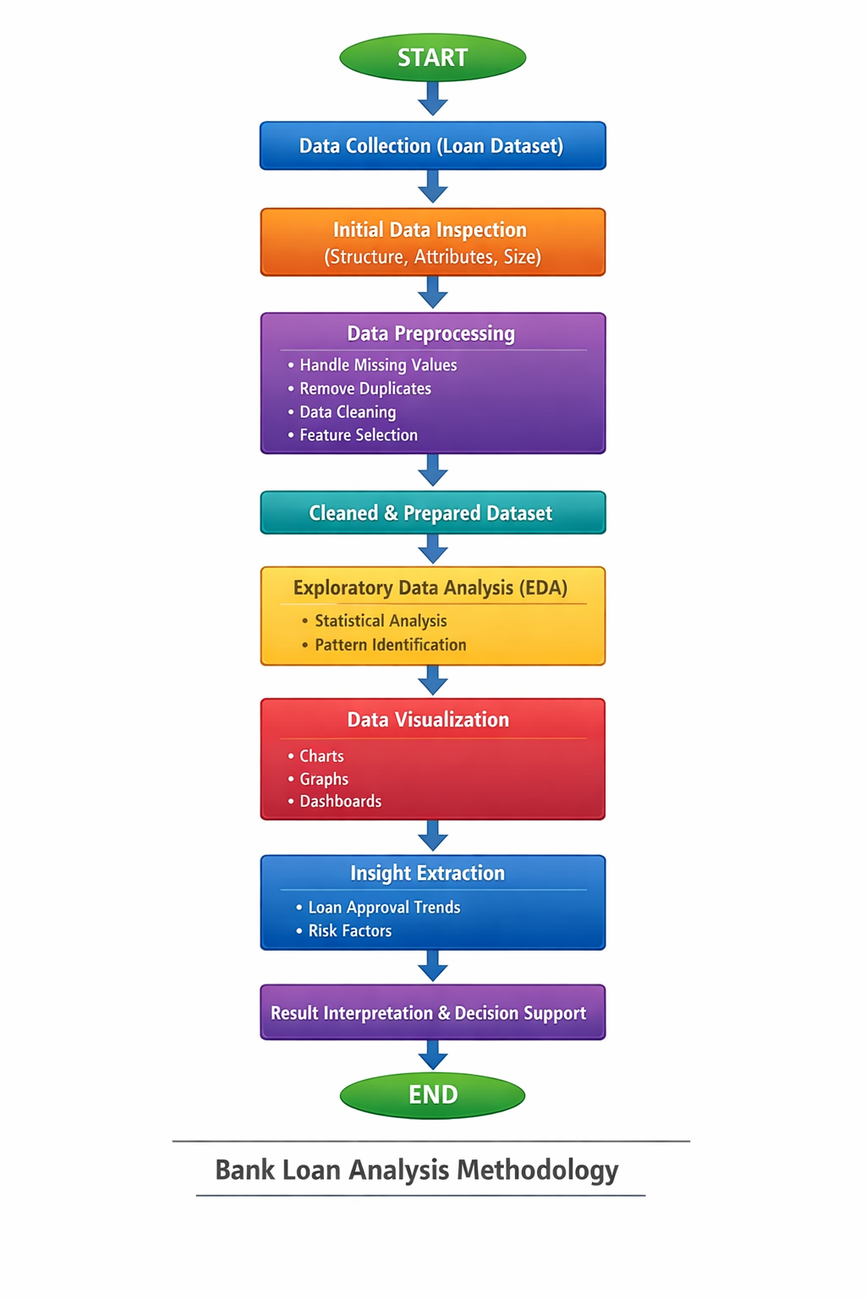
FLOWCHART :

CHAPTER 5: RESULTS

This chapter presents the results obtained from the analysis of the Bank Loan Prediction dataset. The findings are derived from exploratory data analysis and Power BI dashboards. The results highlight key trends in loan approval, risk segmentation, and default patterns.

5.1 Key Analytical Findings
● Approval rate trends :- The analysis shows a clear pattern in loan approval rates across different applicant categories. Overall, a majority of loan applications are approved; however, approval is not uniform across all groups.
Applicants with a good credit history have a significantly higher approval rate compared to those with poor credit history. Income also plays an important role, where applicants with higher total income tend to have better chances of loan approval. Additionally, semi-urban regions record a higher approval rate compared to rural areas, indicating regional influence on loan decisions.
These trends suggest that banks prioritize creditworthiness and repayment capacity over demographic factors alone.

● Risk segmentation :- Risk segmentation was performed by analyzing combinations of income level, loan amount, and credit history. The analysis identifies three major customer risk groups:
● Low-Risk Applicants:
Applicants with good credit history, moderate loan amounts, and stable total income. These applicants show the highest approval rates.
● Medium-Risk Applicants:
Applicants with average income levels or slightly higher loan amounts but acceptable credit history. Approval rates in this segment are moderate.
● High-Risk Applicants:
Applicants with poor credit history, low income, or high loan amount requests. This group shows the highest rejection rate.
This segmentation helps banks identify which customer profiles require additional verification or stricter evaluation.

● Default analysis :- Although the dataset does not directly contain default information, default risk was inferred using credit history and rejection patterns. Applicants with poor credit history and high loan amounts are more likely to be rejected, indicating a higher probability of default.
The analysis reveals that credit history is the strongest indicator of default risk, followed by loan amount and income level. Applicants with strong credit history and balanced loan-to-income ratios are considered safer borrowers.
These findings help banks minimize financial risk by avoiding approvals for applicants with high default probability.

Summary
The results confirm that loan approval decisions are strongly influenced by credit history, income level, and loan amount. Risk segmentation and default analysis provide valuable insights for improving loan approval strategies and reducing non-performing assets.

5.2 Dashboard-wise Analysis

5.2.1 Loan Overview Dashboard

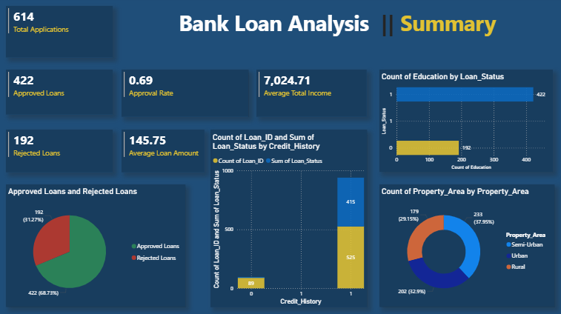

5.2.2 RISK ANALYSIS DASHBOARD
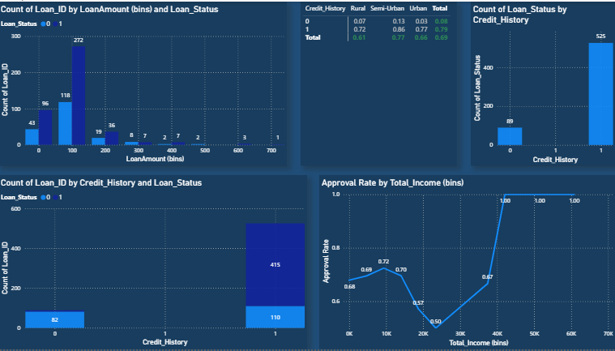

5.2.3 BUSINESS DECISION DASHBOARD
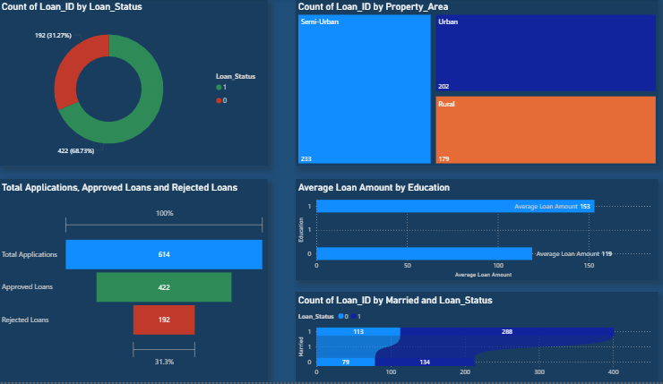

5.3 Business Implications :-
The analytical results of the loan dataset reveal several important business implications for financial institutions. These insights can help banks improve their loan approval strategies, reduce financial risk, and strengthen long-term planning. The following points outline key implications related to policy improvement, risk mitigation, and strategic decision-making.

● Policy improvements :- The analysis highlights the need for more structured and data-driven loan approval policies. Since credit history and income level are the strongest predictors of approval, banks can refine their credit policies by:
● Introducing minimum credit history thresholds for different loan categories.
● Implementing income-to-loan ratio guidelines to ensure customers can manage repayment.
● Updating policies to prioritize semi-urban and urban applicants, where approval success is consistently higher.
These improvements help establish clearer, fairer, and more predictable lending criteria.

● Risk mitigation :- Understanding applicant risk profile is essential for reducing financial losses. This project’s risk segmentation helps in identifying applicants who are more likely to default.
Banks can use these results to:
● Strengthen verification for high-risk applicants with low income or poor credit scores.
● Offer adjusted loan amounts or longer loan terms to reduce repayment pressure.
● Adopt risk-based interest rates, where riskier applicants are charged a higher interest rate.
● Use dashboards for real-time monitoring of high-risk segments.
Effective risk mitigation reduces the chances of defaults and improves the bank’s financial stability.

● Strategic planning :- The insights from this analysis contribute to better strategic planning at management level. The bank can:
● Identify profitable customer segments, such as graduates or high-income earners.
● Redirect marketing efforts toward regions with higher approval rates (e.g., semi-urban areas).
● Forecast loan demand based on income patterns, property area distribution, and demographic factors.
● Use Power BI dashboards to support data-driven decisions for future expansion or product development.
These strategies help the institution allocate resources effectively and improve overall operational efficiency.

Summary
The business implications derived from this analysis support evidence-based decision-making in financial institutions. By improving policies, managing risk more effectively, and aligning strategies with data insights, banks can enhance both profitability and customer satisfaction.

CHAPTER 6 : CONCLUSION AND FUTURE SCOPE

6.1 CONCLUSIONS
The project successfully validated the hypothesis that customer financial behavior is the most deterministic factor in personal loan acceptance. The Power BI solution delivers a measurable framework. Conclusion summarize objectives, methods, and outcomes.

6.2 Limitations of the Study
● Dataset constraints
● No real-time data
● Limited variables

6.3 Future Scope
● Machine learning integration
● Real-time dashboards
● Predictive analytics

List of Figures:

Correlation Heatmap

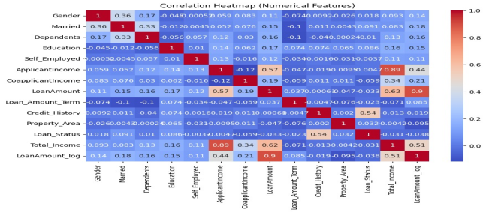

2) Income vs Loan Amount

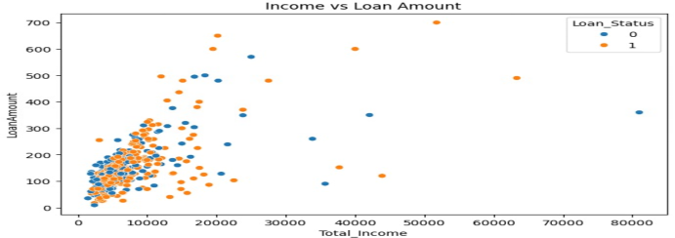

3) Loan Amount Distribution

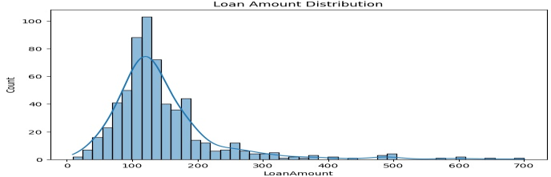

4) Property Area vs Loan Status

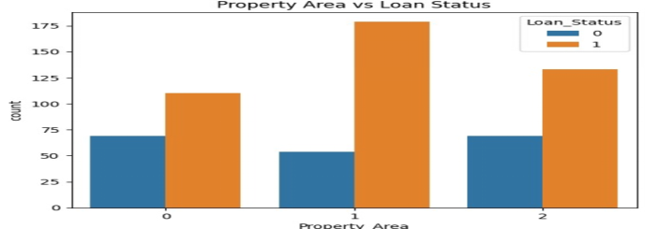

5) Credit History vs Loan Approval

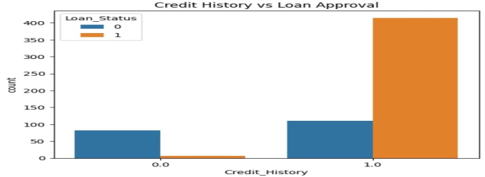

6) Education Distribution

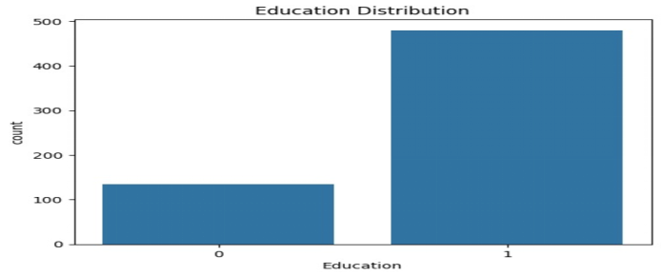

7) Property Area Distribution

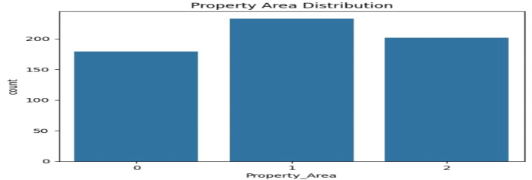

8) Loan Approval Distribution

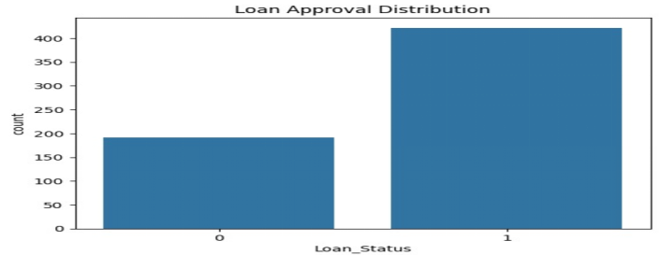

Bibliography

1. Kaggle – Bank Loan Dataset
“https://www.kaggle.com/datasets/anmolkumar/analytics-vidhya-loan-prediction?utm_source=chatgpt.com&select=train.csv”

2. RBI References for Bibliography
a. Reserve Bank of India (RBI):
Master Circular – Prudential Norms on Income Recognition, Asset Classification and Provisioning pertaining to Advances.
Reserve Bank of India, Mumbai.

b. Reserve Bank of India (RBI).
Guidelines on Credit Risk Management.
Reserve Bank of India, Department of Banking Regulation.

c. Reserve Bank of India (RBI).
Report on Trend and Progress of Banking in India.
Reserve Bank of India, Mumbai.

d. Reserve Bank of India (RBI).
Financial Stability Report.
Reserve Bank of India, Mumbai.

e. Reserve Bank of India (RBI).
Handbook of Statistics on the Indian Economy.
Reserve Bank of India.
f. Reserve Bank of India (RBI).
Master Directions on Non-Performing Assets (NPA) Management.
Reserve Bank of India, Department of Supervision.

g. Reserve Bank of India (RBI).
Guidelines on Loan Classification and Provisioning Norms.
Reserve Bank of India.

h. Reserve Bank of India (RBI).
Annual Report.
Reserve Bank of India, Mumbai.

3) Research Papers for Bibliography
a. Predictive Modelling for Bank Loan Approval: From Data to Decisions
Procedia Computer Science, Volume 259, 2025 — This study evaluates various machine learning models for predicting loan approval to improve decision-making efficiency in financial institutions.

b. A Comparative Performance Assessment for Prediction of Loan Approval in Financial Sector
Procedia Computer Science, Volume 258, 2025 — Compares ensemble learning algorithms and classical classifiers to assess loan approval prediction accuracy.

c. Machine Learning Powered Financial Credit Scoring: A Systematic Literature Review
Artificial Intelligence Review, Springer Nature, 2026 — A comprehensive review of machine learning techniques used in credit scoring and their strengths, challenges, and trends.

d. Prediction and Analysis of Financial Default Loan Behavior Based on Machine Learning Model
Computational Intelligence and Neuroscience, 2022 — Explores the use of regression and neural network models for predicting default risk in borrowers.

e. A Review on Loan Approval Prediction Based on Machine Learning Techniques
Journal of Computer Technology & Applications, 2024 — Reviews key machine learning methods applied to loan approval prediction and compares their performance.

f. Loan delinquency analysis using predictive model
International Journal of Knowledge and Learning, 2023 — Focuses on loan default analysis using predictive modelling and feature distribution studies.

g. A Comparative Study of Loan Approval Prediction Using Machine Learning Methods
Gazi University Journal of Science, 2024 — Compares models like Logistic Regression, SVM, and Random Forest for predicting loan approval outcomes.

h. What Best Predicts Corporate Bank Loan Defaults? An Analysis of Three Different Variable Domains
Risks, Vol. 9, No. 2 (2021) — Investigates predictors of corporate loan defaults using logistic regression and neural networks.

4)Power BI Documentation for Bibliography
1. Microsoft Corporation.
Power BI Documentation.
Microsoft Learn, Microsoft.

2. Microsoft Corporation.
Introduction to Power BI.
Microsoft Power BI Documentation.

3. Microsoft Corporation.
Data Modelling in Power BI.
Microsoft Learn – Power BI Guidance.

4. Microsoft Corporation.
DAX (Data Analysis Expressions) Reference Guide.
Microsoft Power BI Documentation.

5. Microsoft Corporation.
Create Interactive Visualizations in Power BI.
Microsoft Learn – Power BI.

6. Microsoft Corporation.
Power BI Desktop – Transform and Clean Data Using Power Query.
Microsoft Power BI Documentation.

7. Microsoft Corporation.
Best Practices for Designing Power BI Dashboards.
Microsoft Learn – Power BI.
8. Microsoft Corporation.
Security, Data Privacy, and Governance in Power BI.
Microsoft Power BI Documentation.

APPENDIX

APPENDIX A: Importing Required Libraries

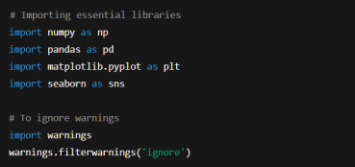

APPENDIX B: Loading the Dataset

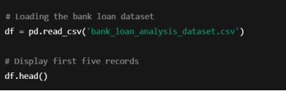

APPENDIX C: Dataset Overview

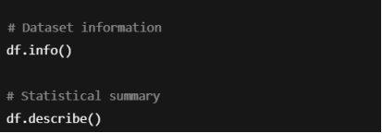

APPENDIX D: Checking Missing Values

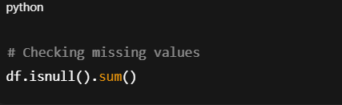

Appendix E: Handling Missing Values

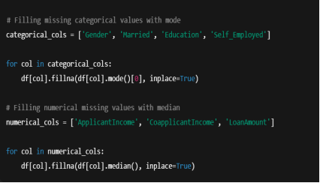

Appendix F: Data Cleaning

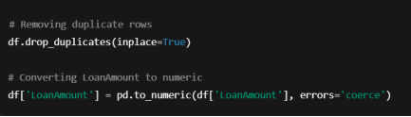
Appendix G: Encoding Categorical Variables

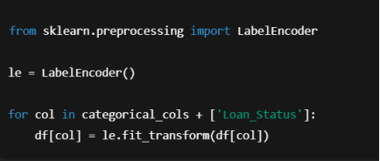

Appendix H: Exploratory Data Analysis (EDA)
Loan Status Distribution

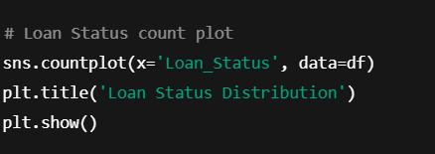

Applicant Income Distribution
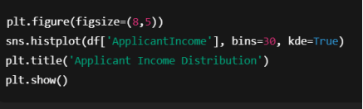

2)Data Set Sample:
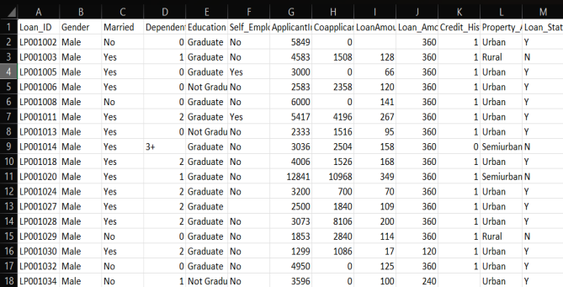

FUTURE SCOPE OF THE PROJECT

To further enhance the project's value, the future scope includes:

1. Machine Learning Integration: Development and deployment of a Classification Model (e.g., Random Forest) to generate a continuous Propensity Score for every customer.

2. Risk-Adjusted Decisioning: Incorporating a model for the Probability of Default (PD) alongside the Acceptance Score to calculate the Expected Profit for each potential loan, ensuring profitability is balanced against risk

REFERENCES

- " Loan Prediction Dataset ", Kaggle. Available:
“https://www.kaggle.com/datasets/anmolkumar/analytics-vidhya-loan-prediction?utm_source=chatgpt.com&select=train.csv”

- M. S. Corp., "Power BI Documentation: Data Analysis Expressions (DAX) Guide," Microsoft Docs, 2024. Available: https://learn.microsoft.com/en-us/dax/

- M. S. Corp., "Power Query M formula language reference," Microsoft Docs, 2024. Available: https://learn.microsoft.com/lb-lu/powerquery-m/power-query-m-function-reference

- T. Hastie, R. Tibshirani, and J. Friedman, "The Elements of Statistical Learning: Data Mining, Inference, and Prediction " 2nd ed. Springer, 2009.

- Python Software Foundation. (2023). Python Programming Language. Retrieved from https://www.python.org

- Kumar, R., & Singh, D. (2021). Data Analytics Techniques for Loan Approval Prediction in Banking. International Journal of Advanced Research in Computer Science, 12(5), 45–51.

